**DATA TYPES, OPERATORS AND**

**EXPRESSIONS IN C++**

**LAB # 2**



**Spring 2022**

**CSE102L Computer Programming Lab**

Submitted by: **Ali Asghar**

Registration No. : **21PWCSE2059**

Class Section: **C**

“On my honor, as student of University of Engineering and Technology, I have neither given nor received unauthorized assistance on this academic work.”

Student Signature: ______________

Submitted to:

**Engr. Abdullah Hamid**

July 4, 2022

Department of Computer Systems Engineering

University of Engineering and Technology, Peshawar

**Lab Objective(s)**

* To be familiar with different data types, Operators and Expressions in C++.

**TASK #1:**

**Title:**

Write a program that takes the temperature in Fahrenheit and convert it to Celsius And Kelvin:

## CODE SCREENSHOTS:

Here is the screenshot of the code.

### 

### **OUTPUT (COMPILATION, DEBUGGING & TESTING):**

Here is the screenshot of the output of above code.

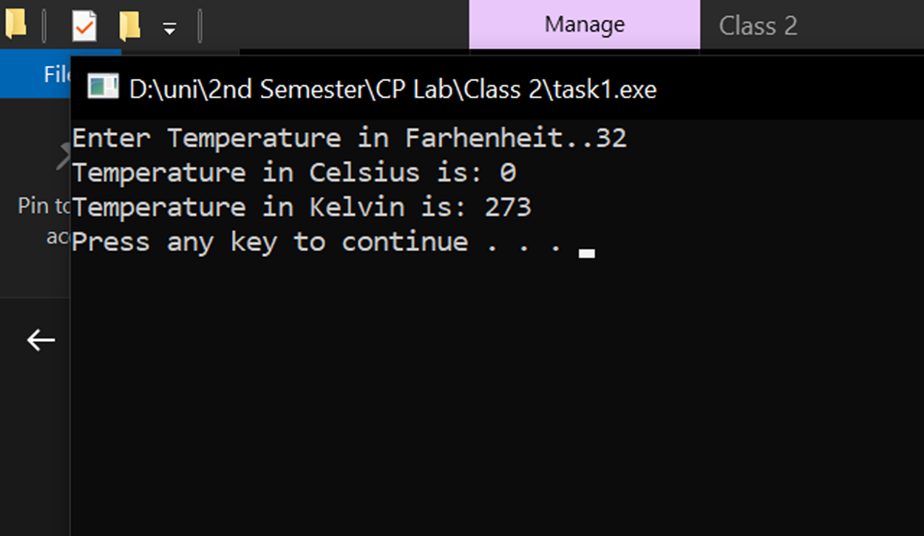

**TASK # 2:**

**Title:**

Write the C++ code that takes the integer a, b, c, d and e from the user and display the output according to the following equation.

## CODE SCREENSHOTS:

Here is the screenshot of the code.

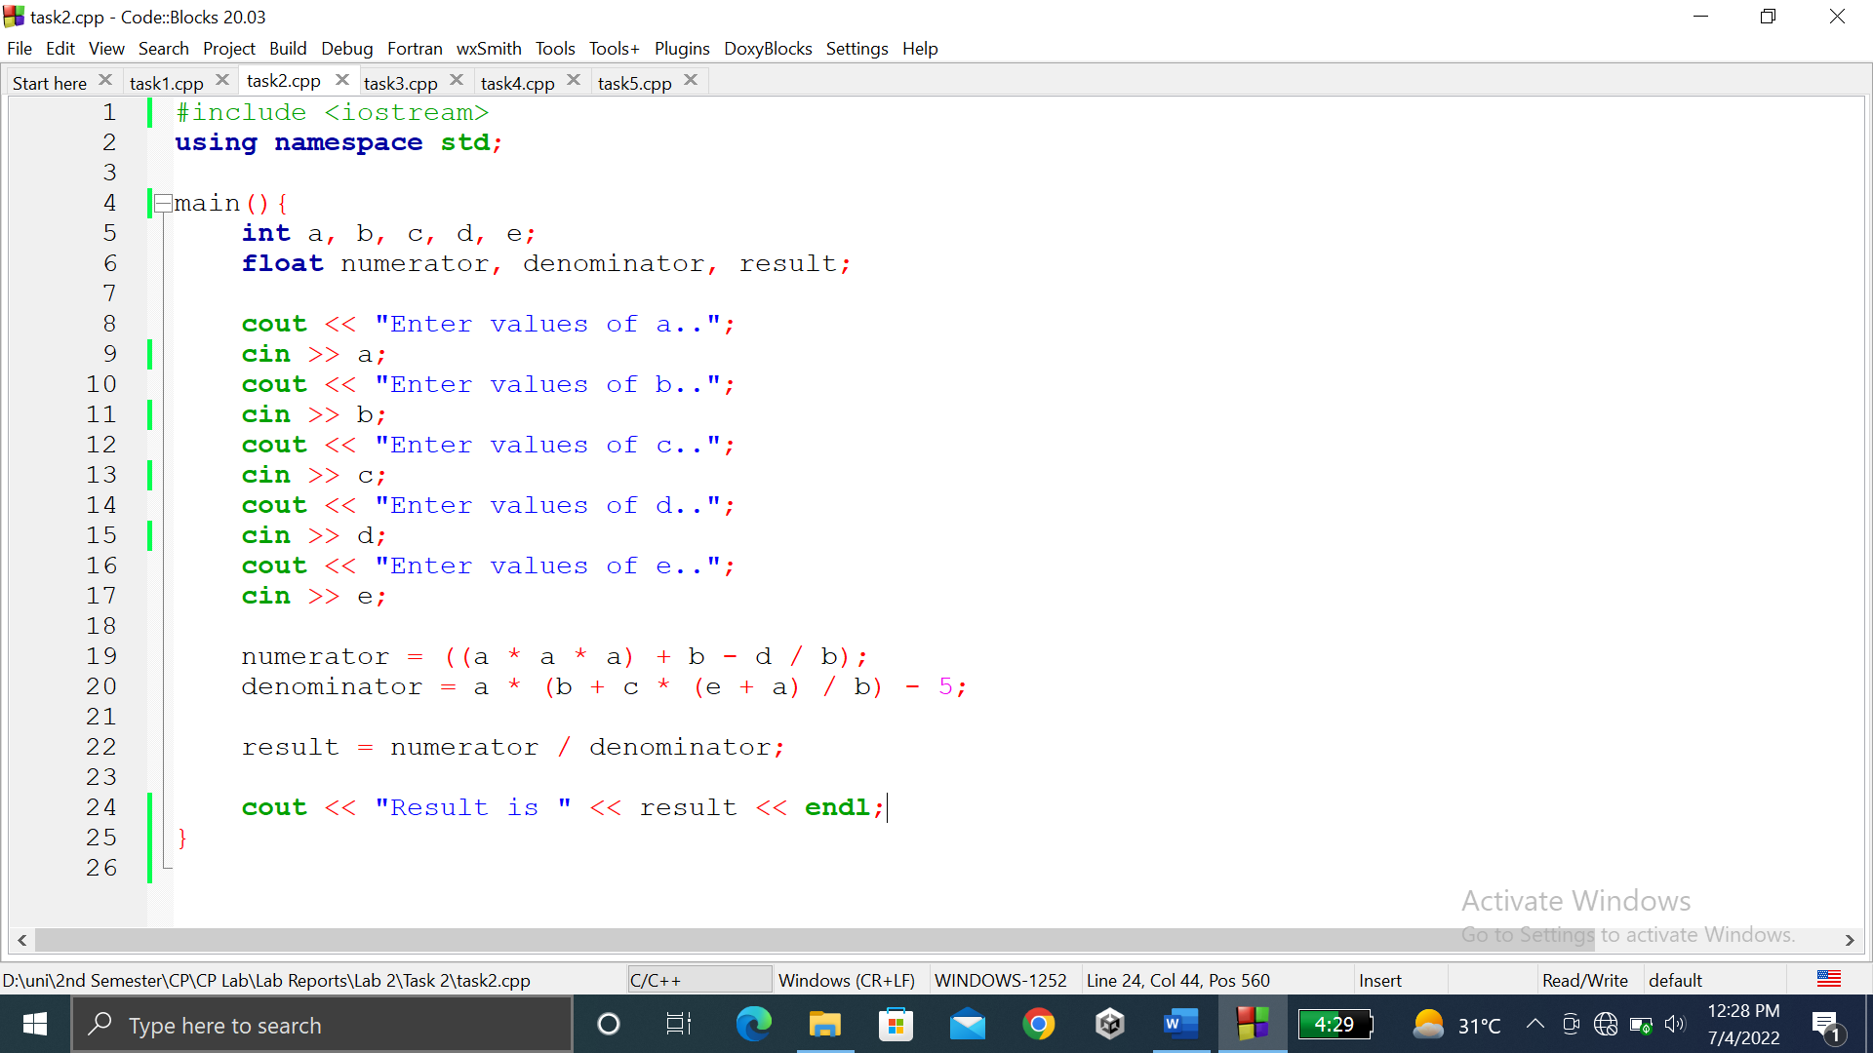

### **OUTPUT (COMPILATION, DEBUGGING & TESTING):**

Here is the screenshot of the output of above code.

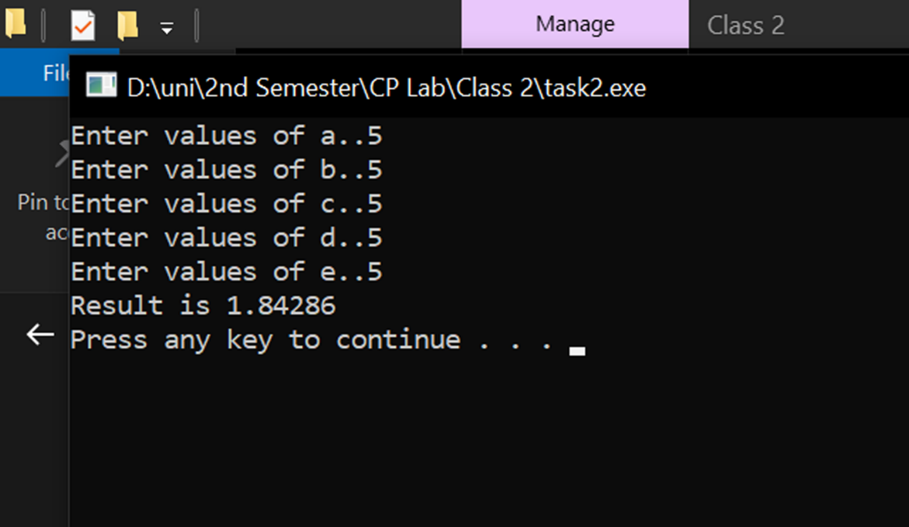

**TASK # 3:**

**Title:**

Write a program to declare two integer and one float variables then initialize them to 10, 11, and 12.6. Also print the variable values on the screen.

## CODE SCREENSHOTS:

Here is the screenshot of the code.

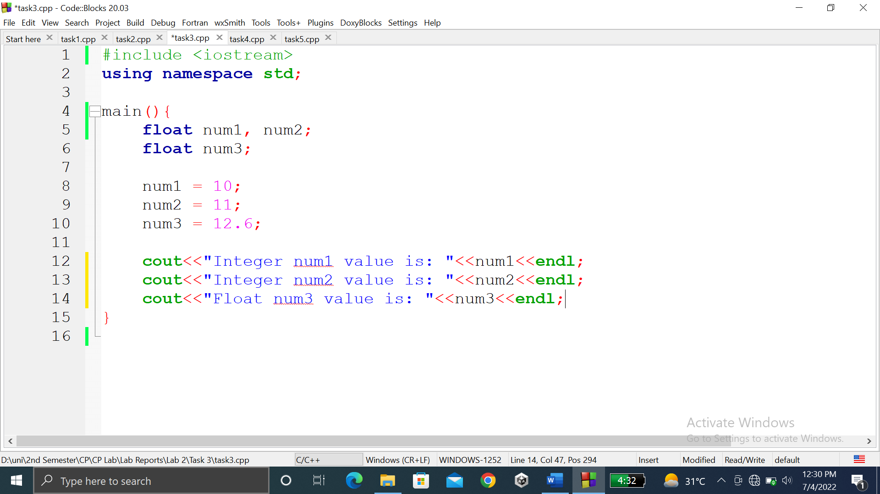

### **OUTPUT (COMPILATION, DEBUGGING & TESTING):**

Here is the screenshot of the output of above code.

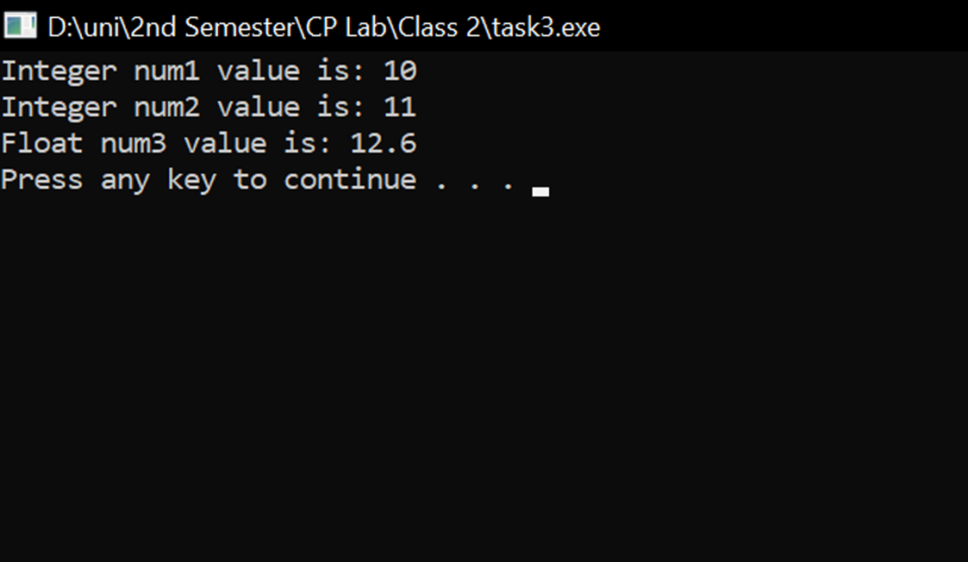

**TASK # 4:**

**Title:**

Write a C++ program to prompt the user to input 3 integer values and print these values in forward and reversed order.

## CODE SCREENSHOTS:

Here is the screenshot of the code.

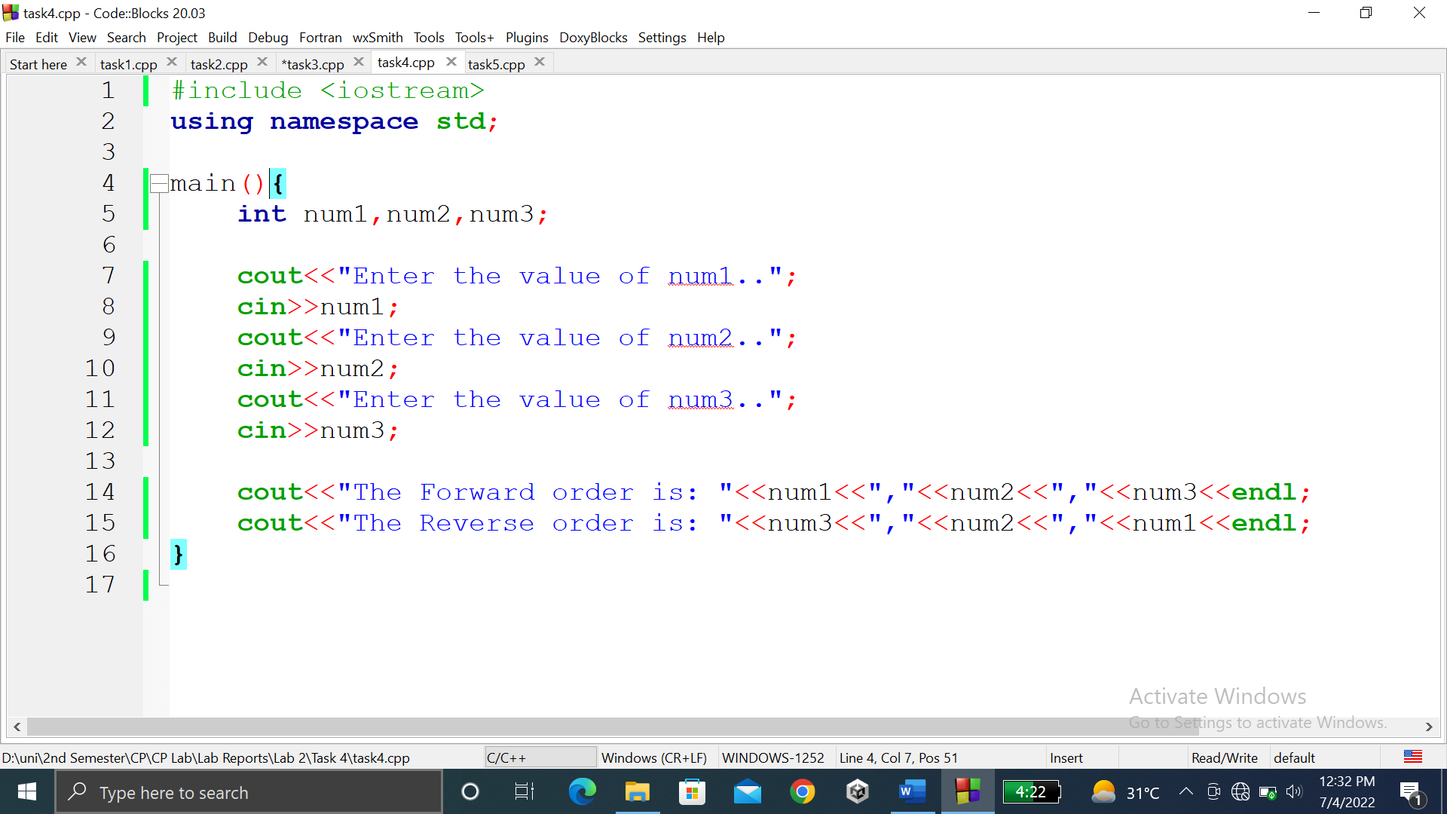

### **OUTPUT (COMPILATION, DEBUGGING & TESTING):**

Here is the screenshot of the output of above code.

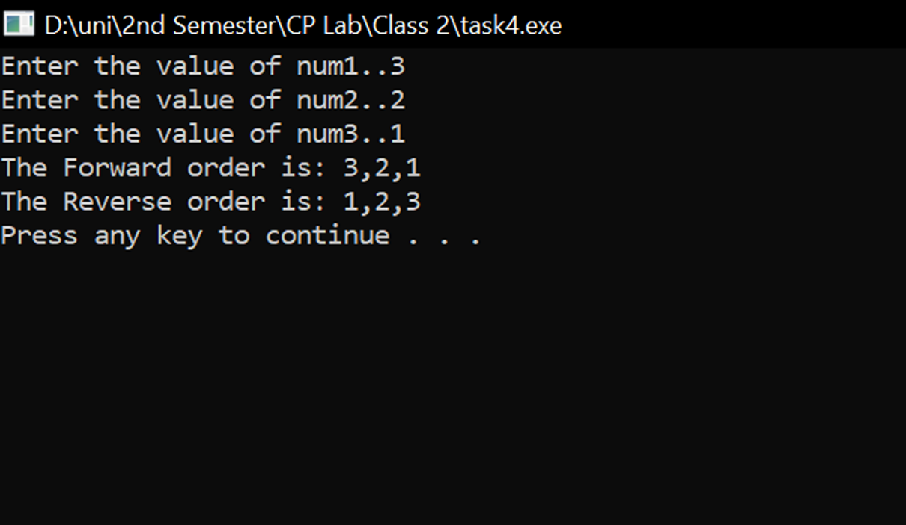

**TASK # 5:**

**Title:**

Write a program to swap two variables values with and without using third variables.

**CODE SCREENSHOTS:**

Here is the screenshot of the code.

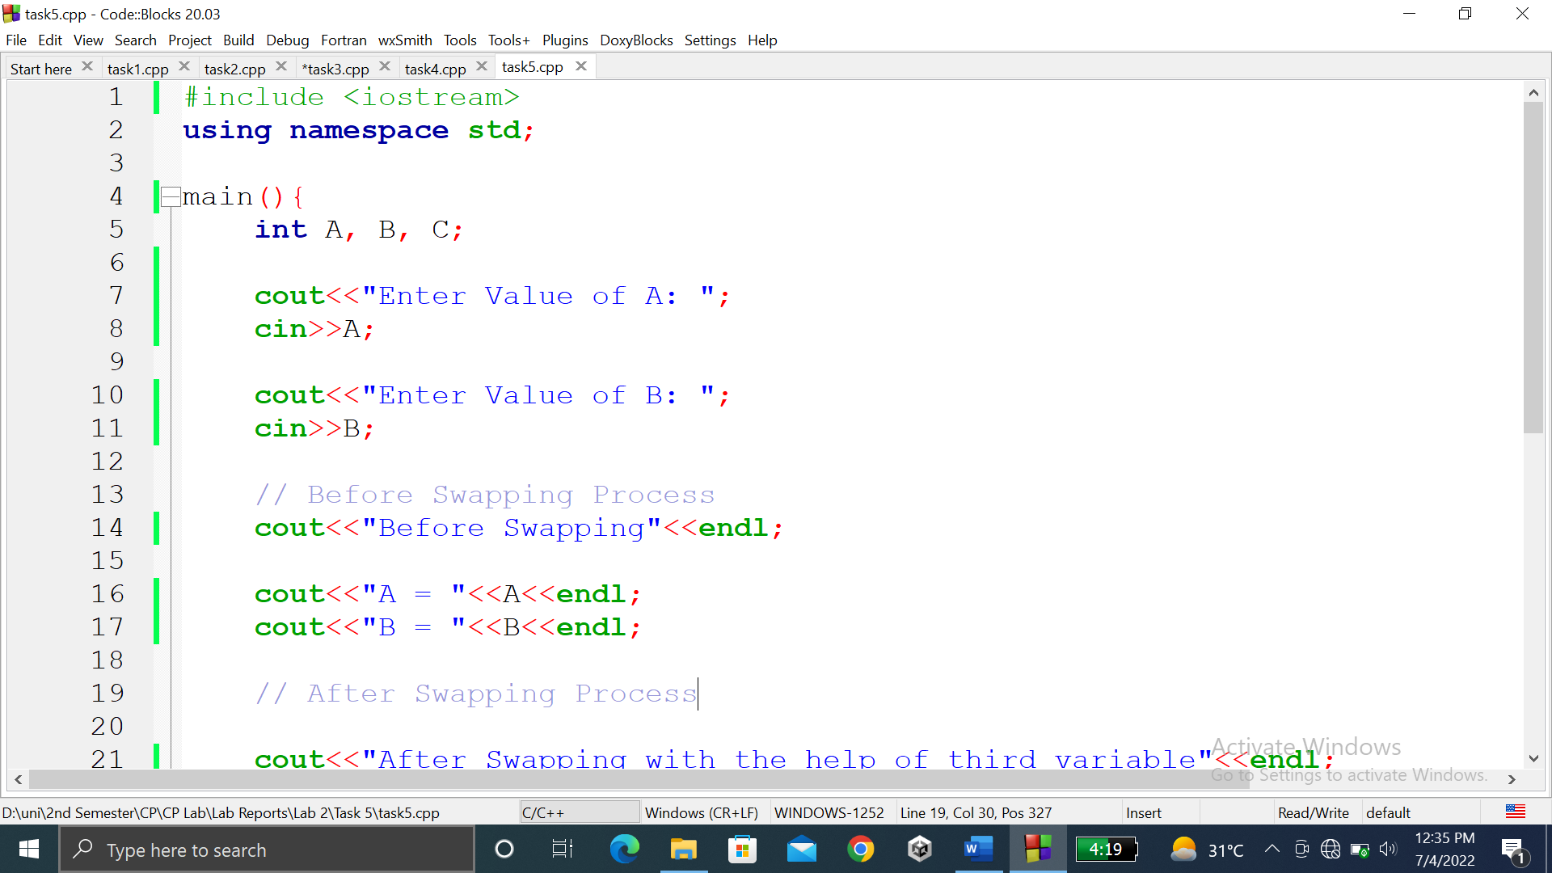

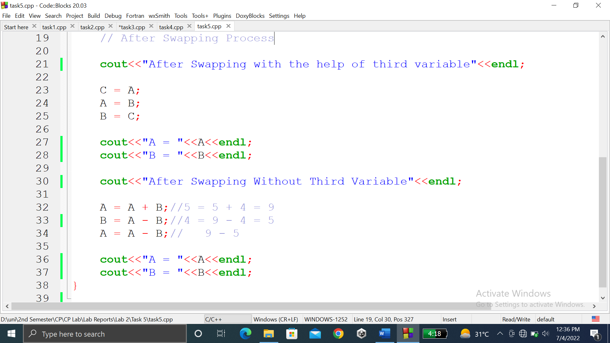

### **OUTPUT (COMPILATION, DEBUGGING & TESTING):**

Here is the screenshot of the output of above code.

